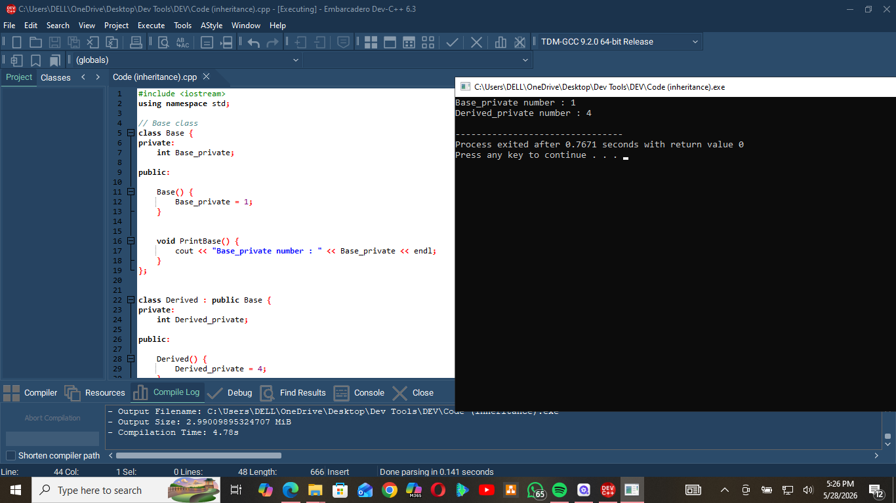
This program demonstrates inheritance in C++.
- Base is the parent class.
- Derived is the child class that inherits from Base.
How the Code Works
Base Class
- Contains a private variable:
int Base_private;
- The constructor sets it to 1.
- PrintBase() displays its value.
Derived Class
- Inherits publicly from Base.
- Contains its own private variable:
int Derived_private;
- The constructor sets it to 4.
- PrintDerived() displays its value.
Main Function
Derived derived;
Creates an object of the Derived class.
Because of inheritance, the object can use:
- PrintBase() from Base
- PrintDerived() from Derived

Output
Base_private number : 1
Derived_private number : 4
- First line comes from:
derived.PrintBase();
- Second line comes from:
derived.PrintDerived();

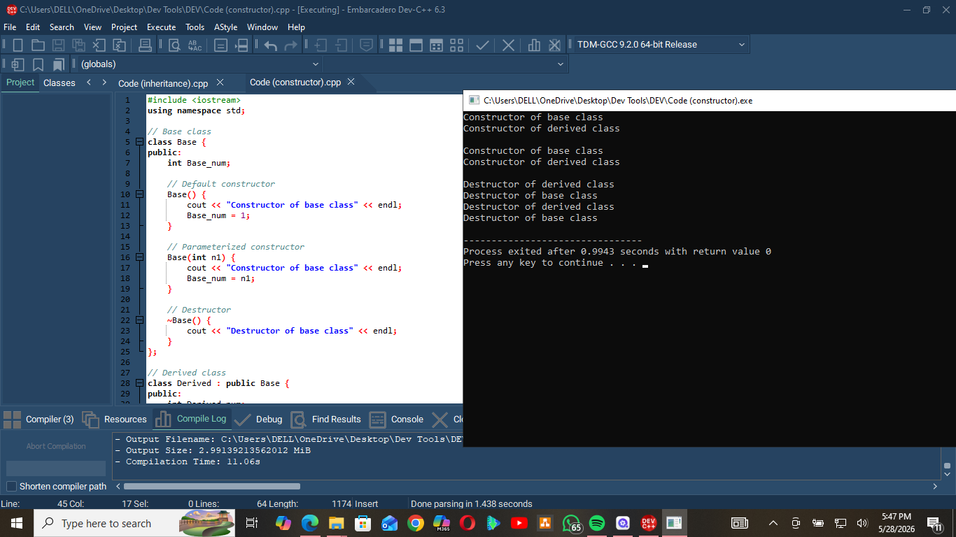
This code demonstrates:
- Constructor inheritance
- Constructor calling
- Destructor order in inheritance

Constructors
When a Derived object is created:
- The Base constructor runs first
- Then the Derived constructor runs
Example:
Derived *ptr1 = new Derived(2);
Output:
Constructor of base class
Constructor of derived class

Calling a Base Constructor
Derived(int n1, int n2) : Base(n1)
This explicitly calls the parameterized constructor of Base.

Destructors

When deleting an object:
- Derived destructor runs first
- Base destructor runs last
Example:
delete ptr1;

Output:
Destructor of derived class
Destructor of base class
This happens because the child class is destroyed before the parent class.

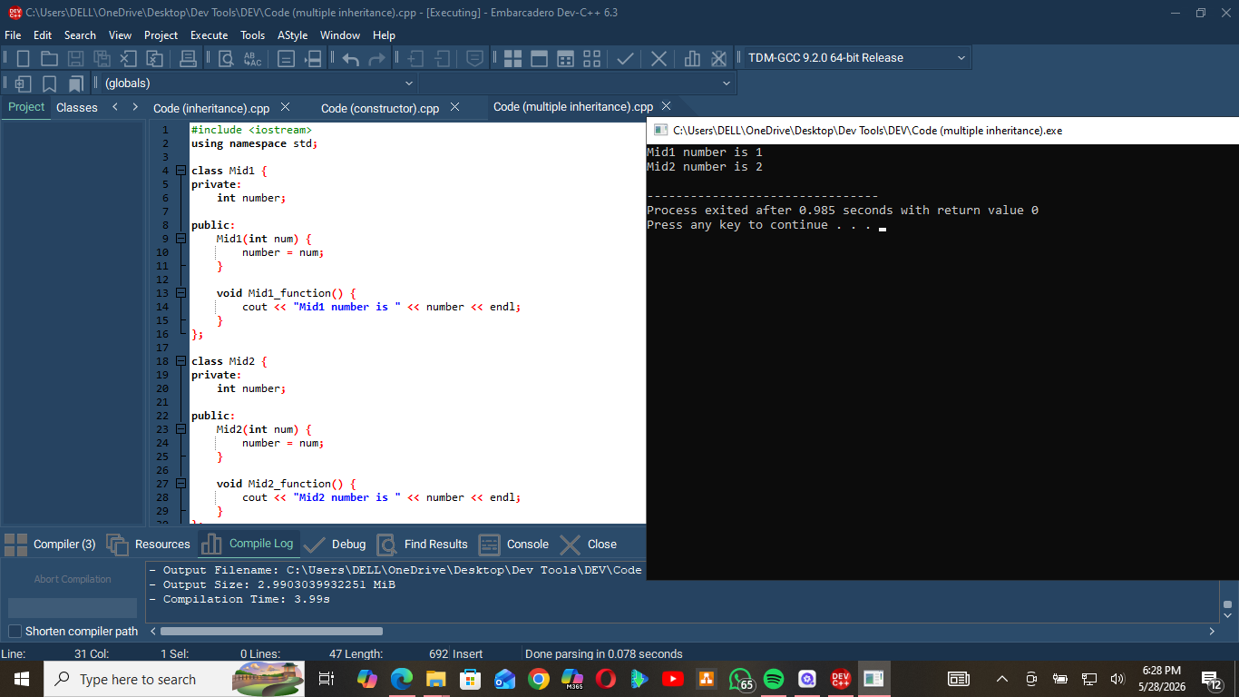
This code demonstrates multiple inheritance in C++.
- Final inherits from:
  - Mid1
  - Mid2
class Final : public Mid1, public Mid2
Constructors
Final(int num1, int num2)
: Mid1(num1), Mid2(num2)
This calls:
- Mid1 constructor with num1
- Mid2 constructor with num2
So:
Mid1 number = 1
Mid2 number = 2
Function Calls
final.Mid1_function();
final.Mid2_function();
These call functions from both parent classes.
Output
Mid1 number is 1
Mid2 number is 2
- First line comes from Mid1_function()
- Second line comes from Mid2_function()
This shows that one class can inherit features from multiple classes.

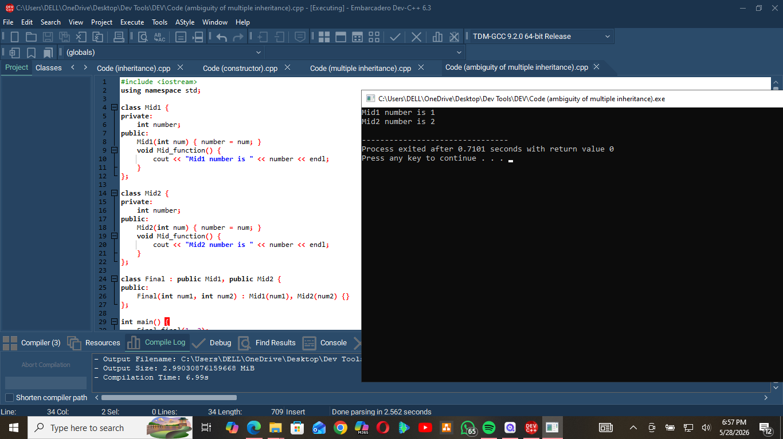
Ambiguity: Both Mid1 and Mid2 have a function named Mid_function(). Without specifying the class scope, the compiler wouldn't know which one to call.
Solution: Use the scope resolution operator :: to explicitly specify which parent class's function to invoke (Mid1::Mid_function() or Mid2::Mid_function()).
Multiple Inheritance: Final inherits from both Mid1 and Mid2, each with their own number member variable initialized via the constructor initializer list.

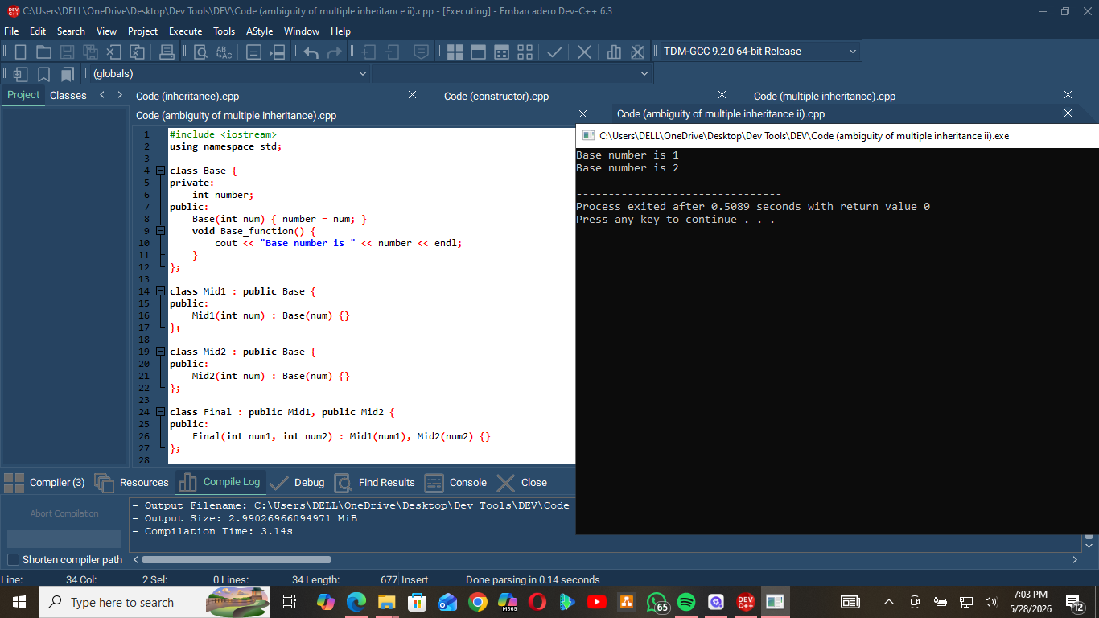
Diamond Problem: Final inherits from both Mid1 and Mid2, which both inherit from Base. This creates two separate copies of Base in Final.
Ambiguity: Calling final.Base_function() alone causes a compile error—the compiler doesn't know which Base to use.
Solution (shown): Use scope resolution Mid1::Base_function() and Mid2::Base_function() to specify which path to use.
Better Solution: Use virtual inheritance (class Mid1 : virtual public Base) to share a single Base instance, eliminating the duplication.

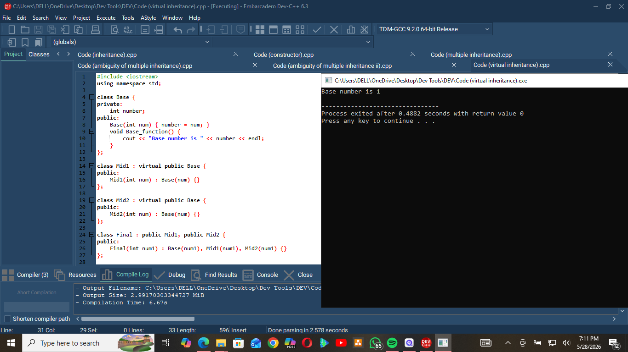
Virtual Inheritance: Using virtual public Base ensures only one shared instance of Base exists in Final, solving the diamond problem.
Key Fix: The most derived class (Final) must directly initialize the virtual base class in its constructor initializer list (Base(num1)).
No Ambiguity: Unlike regular multiple inheritance, calling final.Base_function() works without scope resolution because there's only one Base subobject.
Without virtual: Final would contain two separate Base copies, causing ambiguity.

